May 15, 2019
26

Fake ‘Humanitarianism’ masks murder for profit

Eric Zuesse
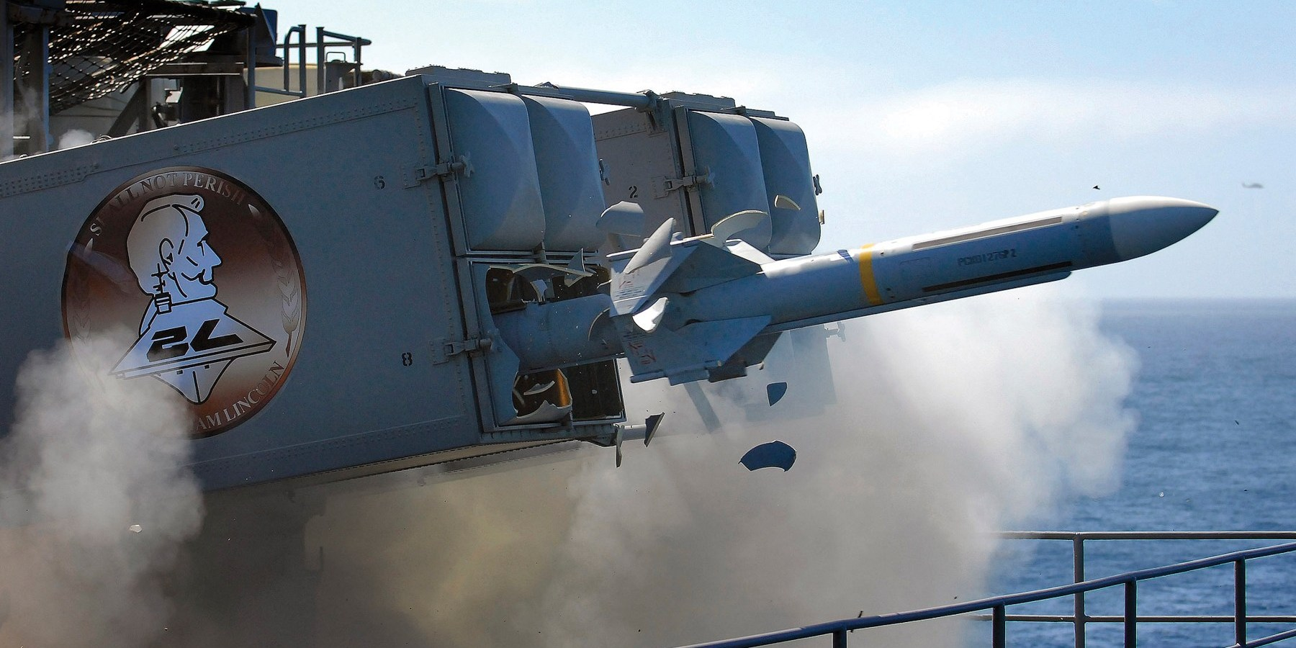
070813-N-4166B-041
PACIFIC OCEAN (Aug. 13, 2007) – A RIM-7P NATO Sea Sparrow Missile launches the Nimitz-class aircraft carrier USS Abraham Lincoln (CVN 72) during a stream raid shoot exercise. U.S. Navy photo by Mass Communication Specialist 2nd Class Jordon R. Beesley (RELEASED)
Unlike a regular corporation, the corporations that manufacture and sell weapons to their government are virtually 100% dependent upon their government and its military allies, for their own success; their markets are only those governments, not individuals (such as is the case for normal corporations).
Consequently, either
- their government will control them, and those firms won’t have any effective control over their own markets, or else
- those firms will, themselves, control their government, and thereby effectively control their markets, via the government’s foreign policies — not only via expanding its military alliances (those firms’ foreign markets), but via its designating ‘enemy’ nations that it and its ‘allies’ (those arms-producers’ foreign markets) can then use those weapons against.
In countries such as the United States, arms-producers are benefiting and controlled by the country’s billionaires, instead of (as in Russia, for example) benefiting and controlled by the government. These totally profit-driven arms-producers need to have market-nations that are called ‘allied’ governments, but they also need to have some target-nations that are called ‘enemy’ governments, so as to ‘justify’ more arms-production by these firms, against which to use these weapons. Only in nations where arms-producers are privately instead of publicly controlled are the government’s foreign polices predominantly controlled by the country’s arms-producers. That’s the way it is in America.
The main ‘ally’ of the U.S. is the Saud family, who own the government of Saudi Arabia. As a recent debate-brief said, “The US has been the world’s leading exporter in weapons since 1990 and the biggest customer is Saudi Arabia. The U.S. sold a total of $55.6 billion of weapons worldwide, and in 2017, cleared $18 billion dollars with Saudi Arabia alone.”
Under Trump, those sales are set to soar, because on 20 May 2017 “U.S. $350 Billion Arms-Sale to Sauds Cements U.S.-Jihadist Alliance” — notwithstanding now the slaughter in Yemen and the slaughter of Jamal Khashoggi. Yet, Trump talks up his ‘humanitarian’ concerns for the people of Venezuela as ‘justification’ for his possibly invading Venezuela, and America’s military is preparing to do that.
- The main and central ‘enemy’ of the U.S. is Russia’s government; and
- all of the other ‘enemies’ of America (the spokes of America’s ‘enemy’ wheel) are led by people — such as Saddam Hussein, Muammar Gaddafi, Viktor Yanukovych, Bashar al-Assad, Salvador Allende, Jacobo Arbenz, and Nicolo Madura — who are friendly toward Russia.
The objective here is to force other nations to join America’s anti-Russia alliances or else to face the consequences of a likely invasion or coup by America to overthrow and replace those leaders. Therefore, America targets all nations that are/were friendly toward Russia, such as pre-2003 Iraq, and such as pre-2011 Libya, and such as Syria, and such as pre-1973 Chile, and such as post-1979 Iran — all of America’s various target-nations, which are the authorized targets for America and its ‘allies’ to invade or otherwise regime-change (change from being a target, to becoming instead a new market).
In order for privately controlled arms-producers to thrive, there is just as much of a need for ‘allies’ as for ’targets’, because without targets, there can be no authorized markets, since every weapon is useless if it has no authorized target against which it may be used. There consequently needs to be at least one ‘enemy’ for any country whose arms-production is privately instead of publicly controlled. Both ‘allies’ and ‘enemies’ are needed, in order for America’s arms-makers to continue flourishing.
By contrast, in Russia, where each of the arms-producers is majority-controlled by the government instead of by private investors, each arms-producer exists only in order to defend the nation, there is no need for any ‘enemy’ nations, and the best situation for such a government is to the contrary: to have as many allies, or buyers of its country’s weapons, as possible (so that it will be as safe as possible), and as few nations as possible that are enemies. For such a country, there’s no benefit in having any enemies. America has publicly been against Russia ever since the end of World War II, and privately and secretly remains against Russia even after the Cold War ended on Russia’s side in 1991.
Whereas the billionaires who control America’s arms-makers profit from this military competition against Russia, the controlling interest in all of Russia’s arms-makers is Russia’s government, which simply suffers the expense of that competition and would greatly prefer to end that competition. It’s just a drain on Russia’s treasury. The profit-motive isn’t driving the arms-producers in countries that control their own arms-makers. The government leads the nation there, basically because the nation’s billionaires — even if they are minority stockholders of the armaments-firms — don’t. And the reason the billionaires don’t is that the arms-producers in Russia are controlled by the government, not by any private investors.
Consequently, in countries that socialize arms-production, ‘humanitarian’ excuses don’t need to be invented in order to create new ‘enemies’. Instead, the goal is for the number of enemies to be reduced, so that the nation itself will be safer. Their arms-producers don’t need constantly to generate (by lobbying, media-propaganda, etc.) authorized targets (‘enemies’ such as Iraq, Syria, etc.), because such a nation, as this, has designed its system to be driven for protecting the public’s safety, and not for any investors’ profits.
If an armaments-firm, in such a nation, goes out-of-business, that’s entirely okay, so long as that nation’s safety isn’t being reduced by ending the firm. The international policy of such a country is totally different from that of a country in which arms-makers’ profits, and not the entire nation’s welfare, is in the driver’s seat regarding all foreign policies.
If arms-makers are being driven for profits, then target-nations are needed in order to expand profits so as to serve their investors. Such a country is run actually for its investors, not for its public. But if the arms-makers are being driven to serve the government instead of to serve private investors, the government is controlling the armament-firms. The nation’s safety is the objective in such a land, because increasing profits for private investors in its weapons-firms is not the company’s objective. Any profits to such investors, are then irrelevant to the government.
It’s truly sink-or-swim, for each of such a nation’s arms-makers — not socialism-for-the-rich, and capitalism (actually fascism) for the poor, such as is the case in the United States.
In a nation such as the United States, the constant need for new wars is being constantly driven by investors’ needs for expanding both markets and targets. And — since in the arms-making business, all of the markets are one’s own government, plus all of its allied governments (no significant consumer-business whatsoever, which is why such firms are fundamentally different from the firms in all other types of fields) — the government needs to serve its armaments-firms, because those firms are totally dependent upon the government, and upon its international diplomacy (to increase the sales of its armaments, and thereby to serve the billionaires who control the armaments-firms).
So: the government there naturally becomes an extension of its major “contractors” or armaments-firms. The politicians know this, though they don’t want to talk publicly about it, because they don’t want the voters to know who is actually in the driver’s seat. They know whom they are actually serving, which is the billionaires who control the armaments-firms. So: those politicians, whatever they might say in public (“America shouldn’t be the policeman for the world,” etc.), always actually vote
- to invade (Iraq, Syria, etc.), and
- to approve the first stage of any war, which is economic sanctions (such as against Russia itself, or Iran, or Iraq, or Syria, or Venezuela, etc.),
and it’s always allegedly being done “to serve God, mother and country” at home, and “to expand freedom and protect human rights in that dictatorially ruled country” abroad.
This is basically the marketing campaign for the owners of the armaments firms. The winning politicians in such countries are the ones that those billionaires support.
In such a country, it’s almost impossible for any politician who is competing for a national office to succeed who isn’t being funded by those billionaires. And, the billionaires’ ‘news’-media support only such candidates.
That’s why there’s almost no possibility for an honest person to be elected (or appointed) to any national public office in the United States.
If a nation’s sole reason for producing weapons is in order to protect the public — a public purpose — then there is no reason for the government to lie so as to demonize foreign leaders such as Saddam Hussein, Muammar Gaddafi, Bashar al-Assad, Salvador Allende, Viktor Yanukovych, and Nicolo Maduro. And this has nothing whatsoever to do with how bad (or good) the demonized leader actually is.
Why does the U.S. government demonize those people, while simultaneously serving (if not actually installing) barbaric dictators such as King Saud, Augusto Pinochet, Castillo Armas, and the Shah? The publicly stated reasons are always ‘humanitarian’ (when not ‘national defense’ — and often, as in 2003 Iraq — both at once). The alleged purpose is to ‘bring democracy to the people there’, and to ‘protect human rights, which are being violated’ by ‘the dictator’ — but it’s actually in order to make suckers out of their country’s own population, so as to serve the billionaires whose income can’t be boosted in any other way than to turn ‘enemies’ (targets) into ‘allies’ (markets) — to conquer those ‘enemies’.
This is just a marketing campaign, and the voters are not the consumers of these products, but they are instead merely the gulls who have to be fooled in order for those profits to keep rolling in, to the (usually) offshore accounts of those billionaires. This is not the type of socialism in which the government controls the economy, but instead the type of economy in which the economy — actually the billionaires who control the armaments-firms — controls the government. This is why it’s “socialism for the rich and capitalism for everybody else.” (The term “fascism” can be used for that.)
This is the New America. And here is the New America Foundation, which is one of the many ‘non-profit’ PR arms of this new America. (That one represents mainly Democratic Party billionaires. Here is one that instead represents mainly Republican Party billionaires.) These are taxpayer-subsidized public relations agencies for their businesses. These individuals are exceptionally gifted businesspeople, because they deeply understand how to fool the public, and they understand that the public never learns and so history just keeps repeating itself, such as in 1953 Iran, and then in 1954 Guatemala, and 1973 Chile, and 2003 Iraq, and 2019 Venezuela, and so many others, ad nauseum. And it goes on and on, for decades if not forever.
But how can the world be protected from such countries? If there is not widespread public recognition that ‘permanent war for perpetual peace’ is a vicious lie, then can there be any other way to do it? Maybe not. Apparently, constant lying by the government and by its (i.e., by its billionaires’) media — and by all of its successful national politicians — is required in any such country.
This seems to be the only effective way to control the public in such a country; and, if the public there aren’t deceived, then the arms-firms’ control over the government won’t even be possible. So, regarding foreign policies, the lying in such a country is constant — especially about foreign affairs.
For example, that explains the stunning findings, in the recent study by a media-watchdog organization, that “Zero Percent of Elite Commentators Oppose Regime Change in Venezuela”. Having something like this happen after Americans were lied into invading Iraq in 2003, is proof that (and it explains why) the public never learns.
This is the way the system has been designed to function, siphoning off the society’s wealth into billionaires’ — largely offshore — accounts. The system is actually set up to operate that way. And the system’s owners (and their media) call this ‘democracy’, and are peddling that ‘democracy’ to the rest of the world.
This is a very successful trick, because — at least until now — the public never learns. (Of course, the system itself is set up so that they won’t.) The public never learns that the actual enemy is the domestic aristocracy itself. But one major American magazine recently made fun of this by headlining “In Billionaires Is the Preservation of the World” praising them as “nature’s own life-preserver” and closing by “With life itself depending on it, how do we determine which billionaires to kiss up to?” The enemy is within, but it’s no joke, and (as Trump makes so clear) ‘aliens’ get the blame, while the domestic aristocracy just get the money.
This type of racket has worked that way for thousands of years, and yet it has always remained “Top Secret,” or (at least) “Confidential” or etc.; but, anyway, very private — and not acknowledged in their ‘news’-media, but instead publicly denied (though, occasionally, also joked-about).
A more-serious phrase for this is “the Deep State.”

Originally posted at strategic-culture.org

